

Wireframe Documentation Home Page

By-Nitin kushwaha ,Mohammad Danish,Diksha Sharma

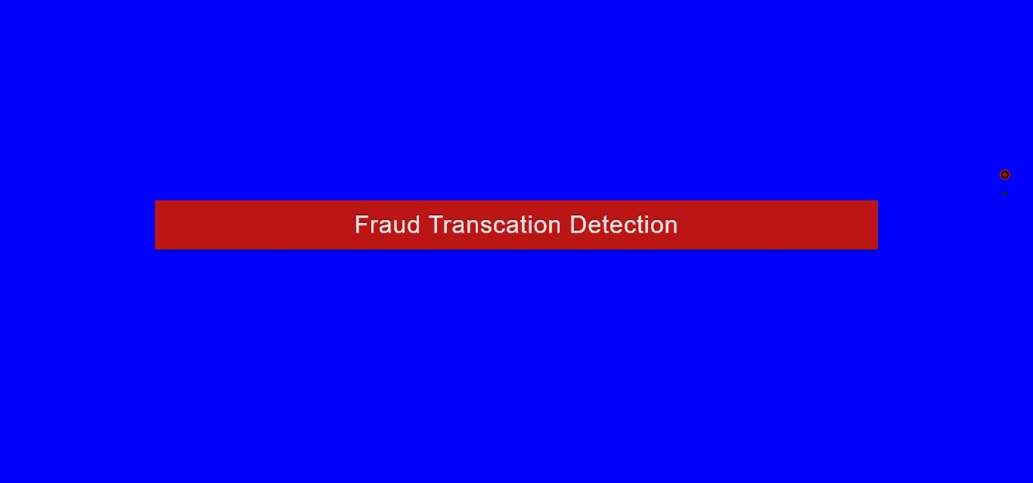

Input

–

Time

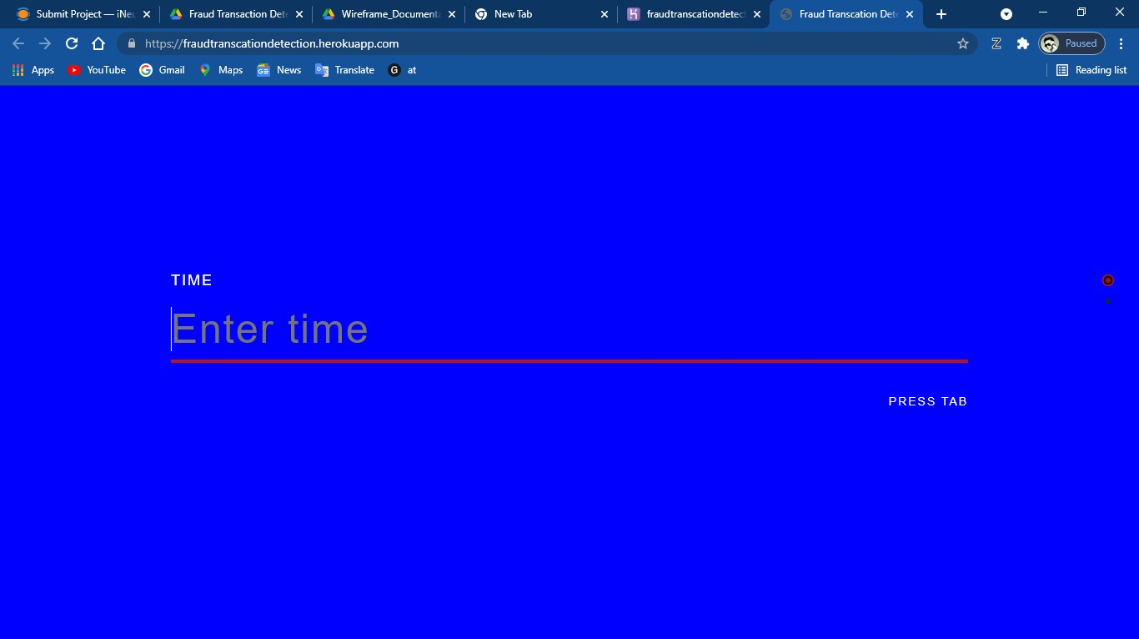

# Input – Amount

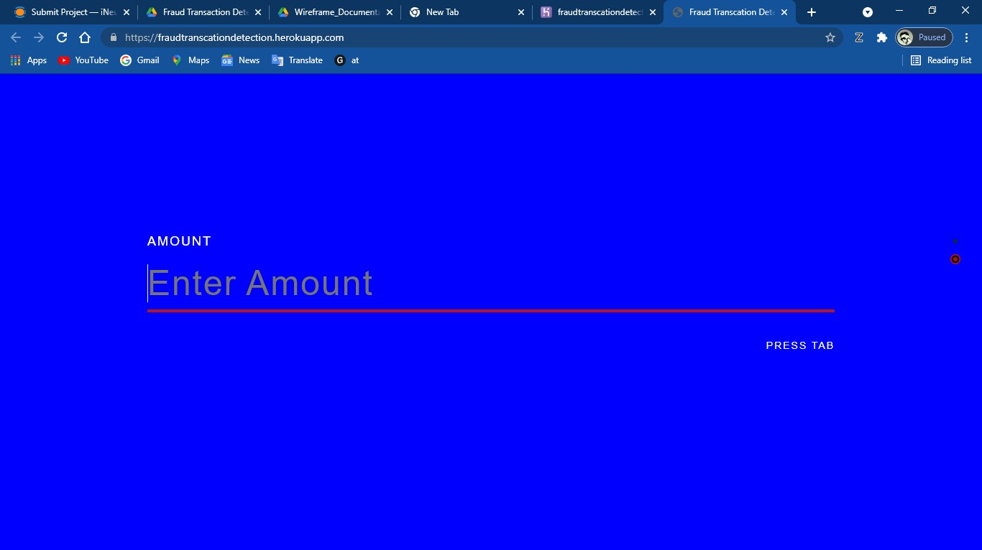

# Output

